Canley Vale Public School
Wellbeing and Discipline Policy 2016

Canley Vale Public School
Wellbeing and Discipline Policy 2016

The CVPS Wellbeing Policy incorporates our Discipline Policy. It is designed using: School Context; Wellbeing Framework; Behaviour Code and; evaluated through the School Excellence Framework.

School Context

Canley Vale Public School is a large and dynamic school located in the heart of South Western Sydney, catering to the needs of students P-6 and their families. The school serves a culturally diverse community with 97% of students identified as English as an Additional Language / Dialect (EAL/D). Chinese, Vietnamese and Khmer are the most highly represented cultures. Newly arrived students and their families are of Arabic, African and Pacific Island background. The school provides a wide range of academic and extra-curricular programs aimed at developing the ‘whole child’. Sound pedagogical practice initiated by teachers, engage students to gain access to a range of learning experiences, which are inclusive and differentiated to cater to individual learning needs, reflecting high expectations. We have a strong Learning Support Team comprising of school counsellors, speech pathologists, classroom and Learning Support teachers. Links between primary and high schools are forged and maintained to promote successful transition between schools. The school has strong ties with the community, encouraging active participation in, and contribution to, the education of all students.

Wellbeing Framework - Enable the school community to Connect, Succeed and Thrive
(Appendix 1)

https://www.det.nsw.edu.au/wellbeing/about/16531_Wellbeing-Framework-for-schools_Acessible.pdf

Rationale

The NSW Department of Education (DoE) is committed to creating quality learning opportunities for children and young people. This includes strengthening their cognitive, physical, social, emotional and spiritual development. Parents entrust their children and young people to principals, teachers and school staff with confidence that schools will deliver on this agenda.

Behaviour Code - Respect, Safety, Engagement

http://www.dec.nsw.gov.au/about-the-department/our-reforms/supported-students-successful-students

Rationale

NSW public schools are committed to providing safe, supportive and responsive learning environments for everyone. We teach and model the behaviours we value in our students.

In NSW public schools students are expected to:

- Respect other students, their teachers and school staff and community members
- Follow school and class rules and follow the directions of their teachers
- Strive for the highest standard in learning
- Respect all members of the school community and show courtesy to all students, teachers and community members
- Resolve conflict respectfully, calmly and fairly
- Comply with the schools’ uniform policy or dress code
- Attend school everyday (unless legally excused)
- Respect all property
- Not be violent or bring weapons, illegal drugs, alcohol or tobacco into our schools
- Not bully, harass, intimidate or discriminate against anyone in our schools.

Schools take strong action in response to behaviour that is detrimental to self or others or to the achievement of high quality teaching and learning.

Behaviour Code for Students: Actions

Promoting the learning, wellbeing and safety of all students in NSW Public Schools is a high priority for the Department of Education and Communities.
We implement teaching and learning approaches to support the development of skills needed by students to meet our high standards for respectful, safe and engaged behaviour.
The principal and school staff, using their professional judgement, are best placed to maintain discipline and provide safe, supportive and responsive learning environments. The department provides a policy framework and resources such as Legal Issues Bulletins, access to specialist advice, and professional learning to guide principals and their staff in exercising their professional judgement. In this context the NSW Government and the Department of Education will back the authority and judgement of principals and school staff at the local level.

Respect:

- Treat one another with dignity

- Speak and behave courteously

- Cooperate with others

- Develop positive and respectful relationships to think about the effect on relationships before acting

- Value the interests, ability and culture of others

- Dress appropriately by complying with the school uniform or dress code

- Take care with property

Safety:

- Model and follow departmental, school and/or class codes of behaviour and conduct

- Negotiate and resolve conflict with empathy

- Take personal responsibility for behaviour and actions

- Care for self and others

- Avoid dangerous behaviour and encourage others to avoid dangerous behaviour

Engagement:

- Attend school everyday (unless legally excused)

- Arrive at school and class on time

- Be prepared for every lesson

- Actively participate in learning

- Aspire and strive to achieve the highest standards in learning

Legal Issues Bulletin www.dec.nsw.gov.au/about-us/information-access/legal-issues-bulletins

School Excellence Framework

https://education.nsw.gov.au/policy-library/related-documents/school-excellence-framework-version-2.pdf

The School Excellence Framework supports all NSW public schools in their pursuit of excellence by providing a clear description of the key elements of high-quality practice across the three domains of learning, teaching and leading.

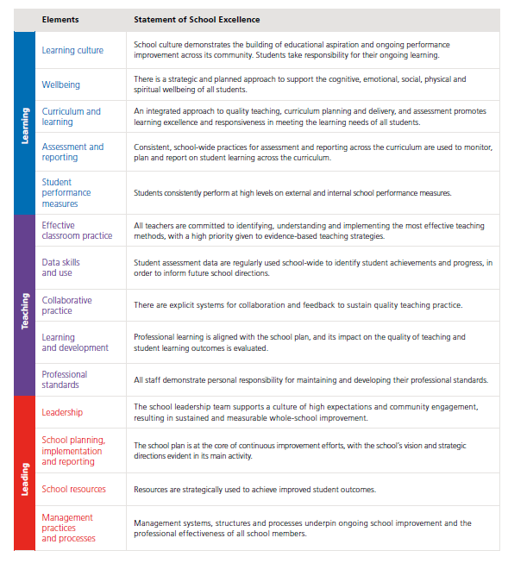

Rationale

Staff

- Staff should read, understand and implement the policy as stated.

- Students are to be made familiar with the steps and consequences of CVPS Behaviour Code.

- Students are encouraged to become self aware and understand their own responsibility to behave respectfully, safely and engage in their learning.

- An Induction Meeting will be held with all new staff each year to outline the policy.

- Parents and carers will receive upon enrolment:
  - Access to the school website to read CVPS Wellbeing Policy
  - A copy of the Behaviour Code.

Classroom

- The school rules must be displayed in classrooms.

- Classroom rules are formulated to reflect the school rules. These are to be displayed in the classrooms and referred to regularly (personalise to your own context).

- Reflect on keywords
- Be Rules
- Wellbeing Framework- Connect, Succeed and Thrive
- Behaviour Code- Respect, Safety, Engagement

Playground

- Warning / time out

NB: Students on DP detention will be assigned to teacher/s on lunchtime playground duty via Deputy, following 1st day detention.

Movement Around School

Encourage:
- Acknowledgement of staff/ visitors (Respect)
- Orderly movement (Safety)
- Utilise the outdoor Learning Environment (Engagement)

Out of School Activities

As school expectations.

Australian Professional Standards for Teachers

Know students and how they learn

(Engagement / Succeed )

1.5.2 Develop teaching activities that incorporate differentiated strategies to meet the specific learning needs of students across the full range of abilities.

Plan for and implement effective teaching and learning

(Engagement / Succeed )

3.2.2 Plan and implement well structured learning and teaching programs or lesson sequences that engage students and promote learning.

Create and maintain supportive and safe learning environments

(Safety / Thrive)

4.1.2 Establish and implement inclusive and positive interactions to engage and support all students in classroom activities.

4.3.2 Manage challenging behaviour by establishing and negotiating clear expectations with students and address discipline issues promptly, fairly and respectfully.

Engage professionally with colleagues, parents/carers and the community

(Respect/ Connect)

7.3.2 Establish and maintain respectful collaborative relationships with parents/ carers regarding their children’s learning and wellbeing.

CVPS Behaviour Code K-2
Rules | Expectations | Consequences
Respect  Be Respectful  Be Honest  Be Co-operative | Treat one another with dignity  Develop positive and respectful relationships to think about the effect on relationships before acting  Speak and behave courteously  Value the interests, ability and culture of others  Dress appropriately by complying with the school uniform or dress code  Take care with property  Cooperate with others | In Classroom  1. Warning  2. Time Out  3. Time Out/ Warning AP  4. To AP / Supervisor  (neighbouring colleague)  Time Out/Warning DP  5. Sent to DP  To Deputy Principal / Principal  6. Loss of Silver Award and one day detention for each rule broken  Return to Deputy Principal / Principal  7. Parents/ Carer Contacted  (Level 4)  Principal Discretion  8. Suspension  (Level 5)  9. Expulsion  (Level 6)
Safety  Be Safe  Be Responsible | Model and follow departmental, school and/or class codes of behaviour and conduct  Negotiate and resolve conflict with empathy  Take personal responsibility for behaviour and actions  Care for self and others  Avoid dangerous behaviour and encourage others to avoid dangerous behaviour
Engagement  Be Your Best | Attend school everyday (unless legally excused)  Arrive at school and class on time  Be prepared for every lesson  Actively participate in learning  Aspire and strive to achieve the highest standards in learning
CVPS Behaviour Code 3-6
Rules | Expectations | Consequences
Respect  Be Respectful  Be Honest  Be Co-operative | Treat one another with dignity  Develop positive and respectful relationships to think about the effect on relationships before acting  Speak and behave courteously  Value the interests, ability and culture of others  Dress appropriately by complying with the school uniform or dress code  Take care with property  Cooperate with others | In Classroom  1. Warning  2. Loss of Privileges  3. Sent to AP / Supervisor (neighbouring colleague)  4. Sent to DP  Loss of Silver Award and one day detention for each rule broken  Return to Deputy Principal / Principal  5. Parents/ Carer Contacted  (Level 4)  Principal Discretion  6. Suspension  (Level 5)  7. Expulsion  (Level 6)
Safety  Be Safe  Be Responsible | Model and follow departmental, school and/or class codes of behaviour and conduct  Negotiate and resolve conflict with empathy  Take personal responsibility for behaviour and actions  Care for self and others  Avoid dangerous behaviour and encourage others to avoid dangerous behaviour
Engagement  Be Your Best | Attend school everyday (unless legally excused)  Arrive at school and class on time  Be prepared for every lesson  Actively participate in learning  Aspire and strive to achieve the highest standards in learning

Reward System

In Class Awards

- Teacher’s choice e.g. Class Dojo, sticker charts, reward box, mini-merits etc.

Beginning of Each Term

- Everyone starts on Silver Award

- Awards are printed and kept by teachers in the classroom

- Teachers to keep a register of Silver Awards

- Silver awards pertain to classroom teachers only. All other staff members to communicate negative student behaviours to classroom teachers

- Consequence of negative behaviour as outlined in the CVPS Behaviour Code

- Everyone has the opportunity to improve their behaviour and retrieve their Silver Award

End - of - Year

- 4 Silver Awards = Gold Award

- Picnic / Sausage Sizzle for Gold recipients

End - of - Year 6 - Exemplary Students

- Any student that has received Gold Awards (for each year at CVPS) = Platinum Pizza Party and award.

NB: Students arriving at CVPS after Term 1 will be eligible for Gold Awards via:

- Correspondence with previous school

- Student Management records

- Teacher discretion

CVPS Behaviour Code K - 2

Classroom Level

Step 1: Teacher warning-> “Time Out = miss out”

Step 2: ‘Time Out’ for continued misbehaviour

Step 3: Repeat misbehaviour – “Time Out again, next time = supervisor”

Supervisor Level

Step 4: Continued misbehaviour, student is sent to Supervisor (neighbouring colleague)

Classroom Teacher then records this in Student profile->

Warning “If you are sent to the DP / Principal you will lose your Silver Award”

Deputy Principal Level

Step 5: Repeated misbehaviour (same day) sent to Deputy Principal with Silver Award.

Supervisor then records this in Student profile.

NB: Repeated misbehaviour (New day)-> repeat steps 1-4.

Student profile-
Click on blue button ……………click profiles…….enter student name->go

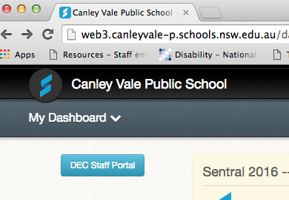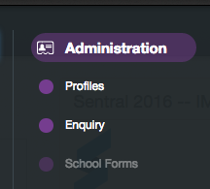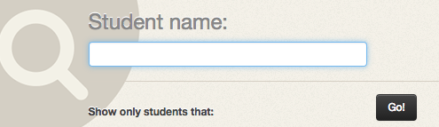
click Support Plans…staff comments……..add new comment
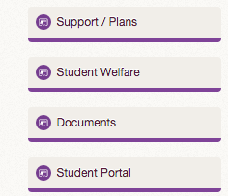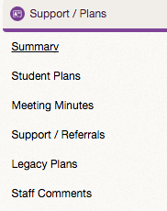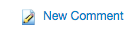

Return of Silver Award
NB: If a student’s behaviour is deemed to have improved by the classroom teacher, then the student is able to retrieve the silver award. The student will sign an agreement for improved behaviour.

CVPS Behaviour Code 3 - 6

Classroom Level

Step 1: Teacher warning-> “Loss of privileges”

Step 2: Loss of privileges

Supervisor Level

Step 3: Continued misbehaviour - > Supervisor (neighbouring colleague).

Classroom Teacher then records this in Student profile - >

Deputy Principal Level

Step 4: Repeated misbehaviour (same day) sent to Deputy Principal with Silver Award.

Supervisor then records this in Student profile.

Student profile-
Click on blue button ……………click profiles…….enter student name->go

click Support Plans…staff comments……..add new comment

Return of Silver Award
NB: If student’s behaviour is deemed to have improved by the classroom teacher, then the student is able to retrieve the silver award. The student will sign an agreement for improved behaviour.

Canley Vale Public School Rules

Respect - students, staff and parents at Canley Vale Public School need to:
Be Respectful
Be Honest
Be Co-Operative

- Treat one another with dignity
- Speak and behave courteously
- Cooperate with others
- Develop positive and respectful relationships and think about the effect on relationships before acting
- Value the interests, ability and culture of others
- Dress appropriately by complying with the school uniform or dress code
- Take care with property

Safety - students, staff and parents at Canley Vale Public School need to:
Be Safe
Be Responsible

- Model and follow departmental, school and/or class codes of behaviour and conduct
- Negotiate and resolve conflict with empathy
- Take personal responsibility for behaviour and actions
- Care for self and others
- Avoid dangerous behaviour and encourage others to avoid dangerous behaviour

Engagement - students, staff and parents at Canley Vale Public School need to:
Be Your Best

- Attend school every day (unless legally excused)
- Arrive at school and class on time
- Be prepared for every lesson
- Actively participate in learning
- Aspire and strive to achieve the highest standards of learning

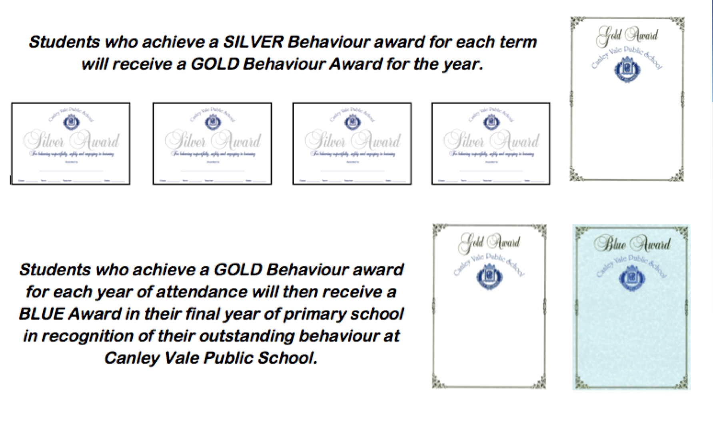

CVPS
DISCIPLINE CHART
ES1-S1
Deputy Principal
Sent to Supervisor
2nd Time Out
Time Out
Warning

CVPS
DISCIPLINE CHART
S2-S3

Deputy Principal
Sent to Supervisor
Loss of Privileges
Warning

Silver Award Review

Date Of Review

Student Name

Initial Incident
Student Response About
Improved Behaviour
Teacher Response
Deputy Principal Response
Deputy Principal Signature

Student Signature

Canley Vale Public School

Our Rules
RESPECT

Be Respectful
Be Honest
Be Cooperative

SAFETY

Be Safe
Be Responsible
ENGAGEMENT

Be Your Best

